**Scenario Development Module Handbook**

**Prepared by Dr. David Blond,**

**QuERI-International, Santa Fe, New Mexico 87501**

**Objective:** Provide a user’s guide to revising scenarios and developing quantitative estimates of impact of changing social, environmental, economic, and political developments on global output and world trade (commodity specific).

**Developing Scenarios**

Scenarios are developed to bookmark possible outcomes of policy or other, non-economic factors. Of course every non-economic factor has an economic consequence. Once human evolution expanded from self-contained tribal or village structures where anything that was needed could be found within a small geographical area, to the global economy man became linked within a causal chain where weather events in one part of the world impact food prices and costs of living in another. Thus almost any event that may appear to be purely political or sociological may also be considered to have an “economic consequence” that needs to be understood and if possible quantified.

**Figure 1: Quadrants Book-mark the Range of Possible Outcomes**

The four quadrants are meant to allow for variations in key factors, but logically there are many possible variants of economic, social, political, and environmental factors that could be used in creating scenarios. Some of the scenarios developed by Shell Oil can stretch to pages of possible future outcomes as it will impact the demand and supply for energy.. Human beings tend to measure effects on a relative scale – 1 to 10, high to low, good to bad – so a graphical interpretation using the quadrants can allow the scenario developer to describe the likely environment for each quadrant.[1] Scenarios need not be limited to economics, but can describe the business environment faced by the company. Figures 2 and 3 offer glimpse of possible scenarios – one related purely to the economic environment within which companies operate and the second specifically geared to the companies business. In this example we relate it to a transportation company primarily because these companies have to operate within the broader global market, but it could as easily be an electronics manufacturer deciding between more innovations at a higher risk of failure or lower prices to ‘milk’ the existing cash cow until the market dries up completely.

**Figure 2: Global Economic Scenarios**



**Figure 3: Company Specific Scenario**



**Other Variants for Scenario Development**

While four quadrants bracket the highs and lows and the inter-relationship between two broad trends, there are many other ways to develop word pictures of the environment we may face in the future. When we read fiction, especially science fiction or alternative histories we are painting scenarios. Historians often contemplate the world that might exist if one historical accident had not happened. If Britain had made a separate peace with Germany in 1940 what might the world look like today is often the subject of speculation (by historians and by novelists). Novelists often develop scenarios as part of their stories. Thus a scenario may be harder to quantify if it involves developing some new device or technology, but it might also open the mind to new possibilities for human transport or ways of life.

For example, imagine a world where the price of energy falls to just under $ 10 a barrel due to either abundant and inexpensive alternatives to drilling for oil (making diesel fuel or gasoline from waste products or abundant and inexpensive nuclear power using existing pure uranium, thorium, or stored nuclear wastes.[2] Lower priced crude would displace governments in the Middle East adding to the poverty there, but enhance the influence of countries able to master the technologies. With energy prices falling, new sources of water might be developed and food production increased in formerly arid, but fertile deserts, leading to increased population and faster global economic growth. These chains of causality are what is important when teams try to develop scenarios to guide their businesses, not in the short term, but in the medium and long term. Identifying small threads that might turn into trends and ultimately into reality are critical to this process of inventive destruction where old business models fall to new ideas.

What this illustrates is that there need not be one method that works. Historically many different approaches have been used. Paul Laudicina, the Managing Director at AT Kearney, a global consulting firm that own uses scenarios as an approach to fostering change within corporate structures highlights some of these in his book ***“Beating the Global Odds: Successful Decision-Making in a Confused and Troubled World***”(Wiley & Sons, Global Finance, 2012) notes that “scenario planning is a process more than a product. It is an iterative development of alternative future visions best done in close collaboration with the leaders and decision-makers who will be using the scenarios as the basis for current future actions.” A scenario must be looked at not just from the point of view of the company, but also from the point of view of the customers of the company, to be truly effective.

Figure 4: History and Methods Used for Scenario Development



**Using the Scenario Planning Module in Excel**

To turn words into numbers effectively we need to use econometric models. These models were developed using data in the vary extensive QuERI Databases[3] that have both historical and forecast data covering 72 countries and range from very aggregated totals of GDP and it’s sub-categories (Consumption, Investment, Government Spending, Imports and Exports) to very detailed estimates of market demand, imports and exports at the 6 Digit NAICS code level NAICS 315220 “Men’s and boy’s cut and sewed apparel”. The importance of this kind of detail makes it possible to translate the effects of economic dislocations into the import demand (and also possibly exports) for specific commodities many of these might go by air or ocean freight. Once the value and real volume of trade is known then it can be translated into weight and cubic volumes).

**Models are crafted to allow the effects that we describe to be factually measured.** Thus we have in our scenarios assumed that when there is a disruption in trade there may also be social effects of an increasing level of poverty in the rural areas driving more people into the urban centers. It has been this urbanization which supports the division of labor and differentiates modern societies from their forbearers. At the turn of the 20th century the country was being transformed from a mainly rural society with some larger population centers mainly on the East coast filled with immigrants into a modern, industrial economy. Farm labor was only partially automated using tractors and harvesters. Today farm labor makes up far less than 1% of the total working population, is highly efficient, and produces multiples of the amounts of food needed to sustain the American population. It is this shift from rural to urban that defines modern, faster growing economies.

But urbanization will slow when economic conditions falter. You take a chance leaving a plot of land which can sustain life and an old house that can provide shelter for the instability of urban life dependent upon finding working and paying someone else to provide shelter, heat, light, and food. Thus when economies are growing, urban populations grow with the rural poor attracted by the hope for a better life. In 2007-8 when exports from China started to fall, migration reversed with workers moving back to the rural areas to survive.

We have two classes of equations in this model – Production and Trade. We use as a proxy for production the GDP despite the fact that this is a too broad measure of economic activity. GDP is a value-added concept that is easy to compare. We combine this with urban population growth when developing an equation for GDP. The combination of GDP and population defines percapita GDP which is a good measure of “wealth”. Many models use the two variables as good proxies for other more “refined” variables. Wealth is a good measure of relative stage of economic development of the economy, while population size, mainly urban population being these people are more in the “money” economy than rural workers in poor countries who use barter or grow their own food and build their own shelter, is a good measure of the size of the market. Larger markets can support more product choices from domestic rather than foreign sources. Smaller markets are by necessity less able to support a range of manufactures and thus must be more integrated with the global economy.

Once the scenario is defined, then a model must be estimated. It is important that the model have at least some of the elements that are included in the word picture. For example, our scenarios involve the combination of government stimulus and international trade. So we want to include these “levers” in the model measuring the impact on output or GDP. Our equation includes these factors along with urban population growth which will be a proxy for economic strength. To allow for differences across countries without bias in the results we split the effect of these variables – Government, Imports, Exports, and Urban Population growth into three groups – advanced countries, emerging markets, and developing. In the spread sheet model you can see the three groups in the way the countries are organized. Interestingly adding up the elasticity’s for each of the groups (advanced, emerging, and developing) comes out to approximately 1.0. Thus 100% of the historical growth in GDP is explained by these factors alone.

**Figure 5: GDP Equation**



**Using Point Elasticity’s**

Each of the coefficients in these models is a point elasticity. A point elasticity has a very good property for this kind of model development as it defines the relationship between the rate of change in the dependent variable (GDP) and the independent factors driving that change, in this case, government consumption (GCON). For every percent change in the variable (year to year) the coefficient explains the likely percent change in the dependent variable, in this case GDP:

1. % GDP(Adv) = (.41*%GCON(Adv)+.04*%AFXWD2(Adv)+.158*%AFMWD(Adv)+.48*%UPOP(Adv)).

Each country has a unique growth path based on these four factors and the rate of change in the independent variables. By knowing the starting value (2012) we can grow then 2013, 2014, 2015, etc. Each year builds on the growth from the previous period.

What if the growth rate for GCON were faster than the baseline or the Washington Consensus, then GDP will be growing at a faster rate unless there are other factors, other variables, that reduce the positive impetus from this stimulus. In ***Terminus*** we have gridlock, little government intervention, even negative growth in government. But in the ***My Country, My Castle*** scenario after a few years the government begins to invest in the economy to support domestic manufacturing through infrastructure and other direct interventions which makes the growth path for GDP different from ***Terminus***. Let’s look at Austria as an example. It’s the first country in the advanced country group. We can see the historical growth rate for Austria – (AF317-BA317). This is the growth rate for GCON in constant dollars for the country over the period 1991 – 2012. We calculate the average growth rate in government spending next, 1.2% and the range around it or the statistical measure called the Standard Deviation which is 1.1%. In the spread sheet there are some cases when the range for these becomes too large and we’ve put some maximums allowed. Without this we can get results that are biased by just one countries pattern when developing group totals. But Austria’s range is consistent with fluctuations up and down in the growth rate. Thus we can say that in 67% of the years the growth rate was within the range (.1% to 2.3%). In some years growth is faster than the average and some years below average. That is the nature of the average. Next we have the *Economist Intelligence Unit* baseline forecast for growth in government spending in Austria for the period 2013 through 2020. This growth rate is sometimes higher than the average and sometimes below the average ( BH317 – BS317).

So when developing a method to show the impact of a change in direction by the government as a result of the scenario we can use these statistical factors to our advantage. The simplest and easiest approach might be to simply assume its 1 or 2 standard deviations above the baseline growth using the standard error calculated (1%). But this would be incorrect. After all the only thing measured with the standard deviation is the likelihood or probability of the actual spending being higher or lower than the average. In some years it will be closer than this upper or lower range. The statistics assume a “normal” distribution in which most of the observations are closest to the average or mean with only a few grouped around the tail. Using a random variable generator that picks a normal distribution between 0 and 1 randomly with more closer to zero than to the upper tail of 1, then we can approximate some kind of future path that will be different from that of the baseline deterministic forecast from the *Economist Intelligence Unit* used as part of the ***Washington Consensus*** scenario. To make this appropriate we have included in the formula a calculated random variable that is between 0 and 1. Note that we are using a normal distribution that is always positive (near zero to 1) rather than one that has both positive and negative numbers. This allows us to insure that the direction of the change based on our scenario assumptions about the direction of change for the key variables to be included.

This offers then a perfect structure then for developing scenarios that adjust the baseline to reflect the shifts in priorities – more government spending in ***Happy Days*** to less spending in the ***Terminus*** to some shift towards more government later in the ***My Country, My Castle*** to replace the benefits coming from exports or to develop new industries to replace imports..

**Figure 6: Adjustment Factors for Government**



Scenario Assumptions tab in the spread sheet is manages the adjustment factors. Using the same example and assuming that we are only changing one factor, all the others being neutral (neutral adjustments are set at “0” in the scenario assumption tab), then we can see how the change in government in happy days is worked into the final result. You should be able to follow the coding in the spread sheet for ***Happy Days***.

1. HD Adjustment to Washington Consensus Baseline = %Adj GDPi(Adv) =.41*(Standard Error[i]*RDN[0 to 1]*%GCONi(ADV)).
2. HD %GDPi = %GDPi WC + %ADJ GDPi(ADV).

We are keeping everything relative to the baseline that was developed using the dynamic QuERI model and based on the EIU assumptions on future growth in GDP. Thus we use the elasticity’s to adjust the baseline growth rates. This is true for the GDP as well as for the import demand for individual products.

Look at ***Terminus*** tab in the spread sheet model and then at AZ3 and you can see the calculations used to develop the adjustment for the scenario compared to the baseline. In this way we show the yearly adjustment on the growth rate. To get back to the value based series we need to BR3 shows the adjusted growth combining the baseline growth and the adjustment to that growth. Finally CX3 takes the 2012 base and moves it forward with the baseline growth and the adjustment to that growth.

**Linked Models – from GDP to International Trade**

Using QuERI detailed trade data (available at the NAICS6 level of detail) and aggregating this into some broad traded product groups, models for imports are constructed. The ***Washington Consensus*** baseline comes from the more detailed set of models developed as part of the QuERI-Integrated Global Model, but we have constructed simplified import demand models that take advantage of the types of variables that are key to defining differences in scenarios. ***This is a critical point in constructing and developing other scenarios. If you want to quantify the effects then you need to include in the statistical models control variables that can be used dynamically.*** For example, if socio-economic effects of educational attainment are in your scenario or perhaps public health, then these need to be a part of the econometric model developed to test the effects. It may be that in doing this you find that none of your beliefs can be quantified or proved statistically. In this case you may want to reassess the scenario or simply add adjustment terms outside of the statistical model to the final results to reflect the “what if” nature of sometimes non-quantifiable changes.

In our trade models we include the following key variables

**Figure 7: Example of Import Demand Model (Agriculture)**

GDP and Urban population growth rates are transferred to the trade models directly from the scenarios. Percapita GDP is used to measure relative wealth and urban population to measure market size and growth. Countries with more urban areas tend to trade more actively with the world at large.

Like in the GDP models outcomes depend upon the degree of integration with the world or the importance of “globalization” in defining the country’s growth pattern – is government a help or a hindrance to the economy.[4] The horizontal axis defines what government is doing to support the economy or to contract it further (by sequester or reductions in the rate of government consumption). The vertical axis defines the degree of global integration for the country. The upper right quadrant is the best of all possible worlds – increased globalization allowing more specialization and efficiency in use of scarce global resources; and increased government spending to make the transition from protected home markets to open, competitive world markets, feasible through help for industries and workers impacted by increased global competition.

In the ***Washington Consensus*** scenario we let current conditions of a relatively open world economy with limited protection. In ***Happy Days*** the degree of embrace of the global system increases as more products are traded internationally. It assumes a faster rate of global trade growth than in the current baseline which is for a modest return to between 5 to 6% growth in global trade rather than the pre-2000 bust rates that were often 8 to 10% globally. In the two alternatives countries raise protectionist barriers.

In the GDP model imports and exports are both positively related to GDP growth. These are not “accounting model” as is the case with the standard Keynesian equation, C+I+G+E-M, where imports are negative to GDP. In the real world growth comes to screeching halt if imports are constrained too tightly, at least in the short-run. In the longer run, countries shift resources and begin to develop domestic sources. This happens in ***My Country, My Castle***. The compensating positive is increased government spending encouraging transitions to a less interconnected world.

**Figure 8: Four Outcomes for World GDP Growth**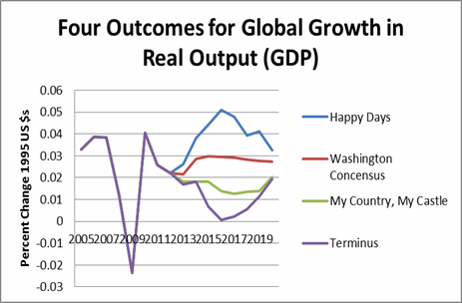

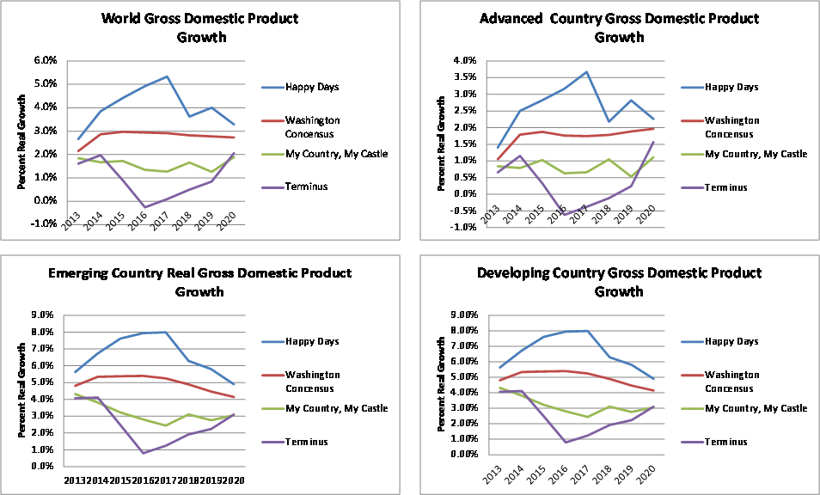

**Adjusting the Trade Models for Scenario Differences**

The trade models use wealth and market size as key variables. Wealth is measured by percapita GDP (Real GDP/Urban Population size) and market size is measured using urban population. The GDP forecast is transferred to the trade models directly. Growth rates for percapita GDP can be measured by the combination of:

1. % Change Percapita GDP = % Change GDP - % Change Urban Population.
2. % Change Urban Population.

These come directly from the scenario as it applies to GDP. The spread sheet model transfers these values into the trade models.

International trade is included directly in both the GDP and the trade model assumptions. In the import demand equations we include information on the export supply capabilities of the countries. The ***Washington Consensus*** forecast data is used and then the adjustments are made on top of this. The effect on any one product of trade integration – measured on the import side by the import share of traded goods (a general variable not tied to any single product) will vary – positively in the ***Happy Days Scenario*** and negatively in the two scenarios dependent upon less trade integration. The Traded Goods share variable has differing impact on demand for imports for various products. With greater integration, as is the case in ***Happy Days*** more traded products come in and the goods share increases due to the introduction of new and varied traded products. ***Terminus*** with the most severe restrictions on imports shows the most adjustment in the traded goods share of total output, while in ***My Country, My Castle*** the downward shift (away from traded to non-traded products, i.e. services) is less as we assume that the domestic producers take up some of the slack left by the reduction in imports.

The price of imported products will also change but for different reasons. In ***Happy Days*** the positive impact of more trade, open markets, may lead to slightly higher import prices. Supply constraints and the robust demand coming from ***Happy Days*** globally allows for more price increases. In the two anti-trade scenarios the government introduces tariffs on imports which raise domestic prices to limit demand.

Each of these adjustments has an impact on demand traded goods, but the effect differs depending upon the elasticity’s calculated for different traded imports. The degree varies and you can see this in the models for trade. Look closely at which products are sensitive to price changes. Given that transport costs are part of this even if we can’t implicitly pick this up in the general commodity price indices we use, then changes in transport costs could have a marginal impact on trade and volumes.

**Figure 8: Scenario Assumptions** 

**Figure 9: Some Graphical Examples of the Scenarios on Trade by Product Groups**

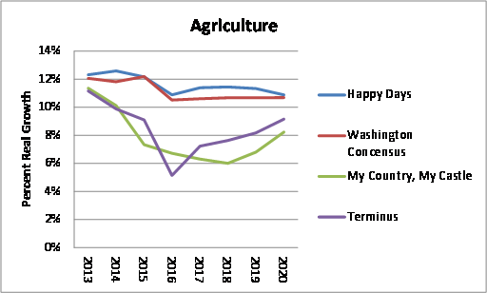

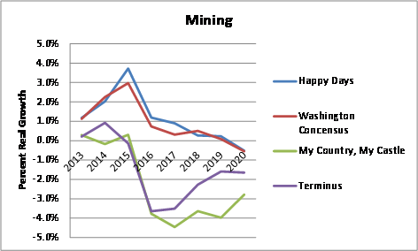

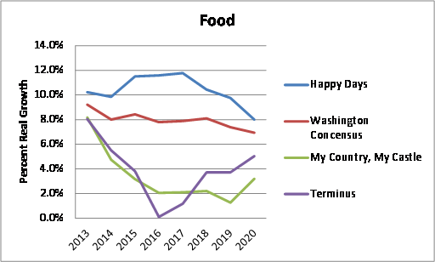

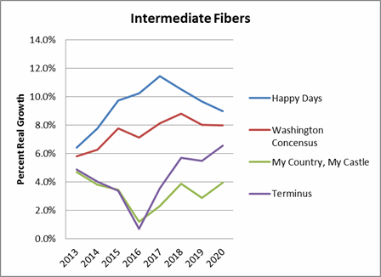

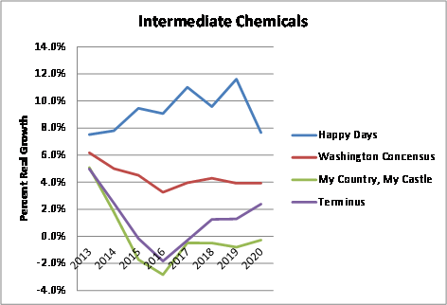

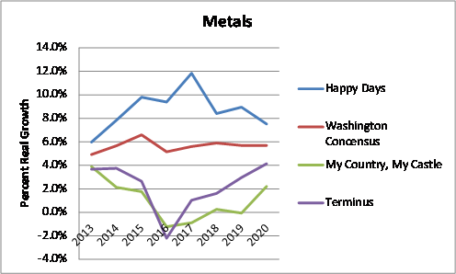

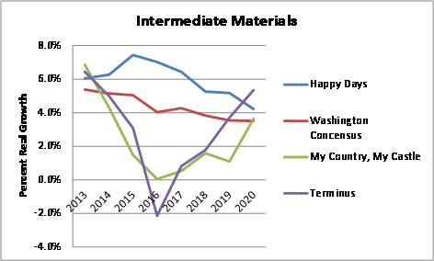

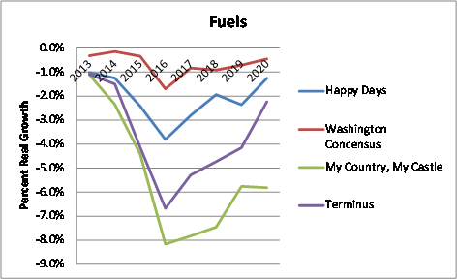

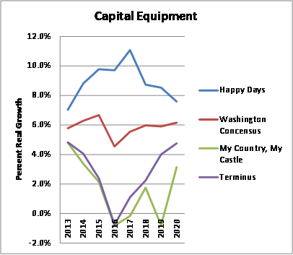

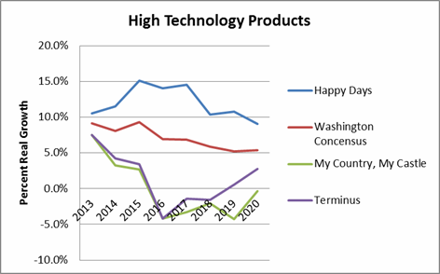

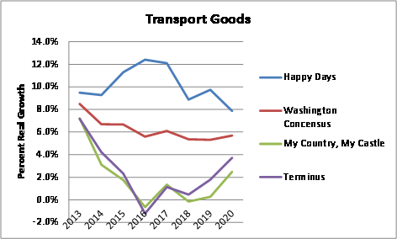

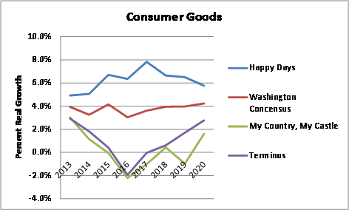

**How to Modify Scenarios – a Primer on Using the Longterm Scenario Model Workbook to Develop Alternatives**

The Model Workbook has been modified to include an additional scenario along with the four pre-packaged scenarios used in the initial course. This new, or Generic Scenario, is used to allow analysts to develop an alternative without impacting the pre-packaged scenarios.

*Before we go on further, however, we need to discuss the issue of fixed versus random events. The Excel spread sheet includes random number generators. The nature of spread sheets is that any change made in the spread sheet will cause the entire spread sheet to be recalculated. We include random number generators in the calculation of the effects which makes the scenarios more realistic, but also introduces variability. Thus each time any change is made some of the numbers in the forecasts will change slightly. This happens if the f9 key is pressed or if you access and change any cell anywhere in the spread sheet. To fix a final result the analyst must copy and past the final results into a new page using the fixed copy function.*

The Generic Framework Model

Each model set consists of the following pages and if another scenario needs to be developed then these pages have to be copied and then modified to reflect an alternative scenario. ***The best way to do this is to make a copy of the base Excel spread sheet and call it by another name. Modify this spread sheet rather than the original that is set to zero.***  The spread sheet is set up to allow a change to be made in the Scenario assumptions tab of the spread sheet. This will put all the factors into the cells in the various pages of the spread sheet. ***The link is from the assumptions tab to the GDP model tab and to the Agr tab. All the trade pages are linked to the factors assumed in the Agr tab.*** In this tutorial we will go through the steps needed to modify the “generic” scenario.

Each scenario has 13 individual page tabs associated with it. The starting point is the Scenario Assumptions tab and it then makes changes in the GDP Model and from there to the various trade models.

1. *Generic – GDP Model framework*
2. *Generic Summary – Integrates the results from the baseline and the alternative for each element (GDP, Trade categories)*
3. *Generic-Agr - Trade model for Agricultural products*
4. *Generic-Min – Trade model for Minerals*
5. *Generic-foot – Trade model for footwear*
6. *Generic-IntFib – Trade model for Intermediate Fibers*
7. *Generic-Intchm – Trade model for Intermediate chemicals*
8. *Generic-Mat – Trade model for metals and materials*
9. *Generic-fuels – Trade model for energy products*
10. *Generic-capital – Trade model for capital equipment*
11. *Generic –htech – Trade model for high technology equipment*
12. *Generic-tequip – Trade model for transport equipment*
13. *Generic-consumer – Trade model for consumer products*

Each trade and GDP tab take information from the initial Scenario Assumptions tab. The spread sheet is constructed so that filling in the adjustment factors in the scenario assumptions tab will input these adjustments in each country of the model scenario tables. The linkages are between the scenario assumptions and the macroeconomic model framework model (GDP) and also linked directly into the first of the trade model, Generic-Agr. From this point all the adjustments are linked to the Generic-Agr file.[5]

**Step-by-Step Guide to Creating a New Scenario**

The Generic Scenario is in its neutral position, all zeros, thus it is the same as the baseline or Washington Consensus. While the simplest approach would be to modify the Scenario Assumption tab in the spread sheet and this will automatically change all the factors in the models, but another, possibly more useful approach may be to selectively to change single assumptions in the individual tabs. To illustrate this let’s create what may be a quite plausible scenario that will definitely have an impact on UPS ocean and air trade if either one or both of these proposed new international bilateral trade pacts are approved. Currently meetings are being held on both sides of the Pacific and the Atlantic to negotiate two potentially huge trade agreements. The first is the North Atlantic Free Trade Agreement mentioned by the President in his State of the Union address and the second the Transpacific Free Trade Agreement. The former would link the European Union countries with the NAFTA countries and the later might be a less complete agreement linking selected countries in the Pacific region together (Australia, Chile, Japan, Malaysia, New Zealand, Singapore, US, Canada). Missing from this are China, Hong Kong, Taiwan, South Korea (there already exists a treaty with Korea on trade). But meetings are being held and it is possible that other countries in the region might be included the Philippines, Indonesia likely will have to be included, but for purposes of this scenario we assume that any country along the Pacific coast from Terra del Fuego to Point Barrow in North and South America and nearly all the countries in the Pacific region, excluding Russia’s Far East are in the final agreement. .

To illustrate this we have to make some general assumptions about what free trade might mean for economic growth and trade. Our model is a stochastic model that works off of historical averages of growth rates combined with random scaling agents, it doesn’t work by revising market shares or adjusting down prices by a fixed amount that might come when tariff levels are reduced. Thus we have to be subtle in the adjustments we make from these type of agreements.[6]

A second complication has to do with the degree of current dependency between the regional players. Potentially we are looking at the relationship between North America and Europe and Asia and North America. Again these are in terms of shares thus any change in the total imports or exports that we allow in the scenario using the adjustment factors must be in relationship to the regional trading concentrations. Figure 11 shows for each of the regions the shares for exports and imports with other regions.

We will make assumptions about the adjustment factors to be applied using information then from Figure 10 and Figure 11 to develop scenario that assumes that both trade agreements are signed and begin implementation starting in 2015 and reaching full implementation by 2017 (2015 = ¼, 2016 = 1/2, and 2017 1.0).

**Figure 10: Potential Members of the North Atlantic and Trans-Pacific Trade Agreements**



**Figure 11: Regional Trade Share Matrices (Export Shares and Import Shares)**



**Some Assumptions About Effects**

Around 18% of North American trade goes to Europe in 2012, but by 2015 the share will be less 18% and decline further to 16% by 2020. For North America’s outbound trade around 17% goes to Europe and will decline to a similar 16% by 2020. For European countries the shares are different 7% outbound and 5% inbound. To develop a scenario we need to take into account these “facts” since it is obvious the impact of an agreement will be larger for North American exports and imports than for European exports and imports. A second element in any deal is the reduction in prices. Tariffs are on average quite low already in both the European Union (4%) and into North America (US and Canada, with higher rates for Mexico from outside of the NAFTA free trade zone). The US tariff average is around 5% and 4% for Canada. Thus any change will be quite small in total trade, but the effect should be greater for the US than for Europe. So we can use the shares as a guide for the adjustment to apply to the standard errors of the rates of change.

North America will also enter a similar agreement with a large group of Pacific-rim countries. We’ve included China in this as well. Looking at the Asian shares with North America we have a similar difference between outbound and inbound trade for the two groups. Thus the impact on North American countries should be greater given the higher concentration of trade both inbound and outbound from both agreements.

**Figure 12: Summary of Regional Shares**



In the models we have adjustment factors for Imports and Exports, trade shares, and import prices. Assuming the schedule of implementation – ¼ in 2015, ½ in 2016 and 1 in 2017, then we can use this to be the adjustment factor times the existing shares which reflect the importance. This will be a small, but likely reasonable effect of any trade agreement given that there already exists a sizable amount of a countries trade with the region.

Prices can be adjusted using the average tariffs with the same proportions. The effects will be quite small as a result. It is likely that the increased competition especially in the huge US market from both directions will drive prices down further than the loss of the 5% tariff amount. To accomplish this we assume that prices drop immediately by the tariff levels in the first year, twice the tariff level in the following year. These are quite modest, but with some countries having very significant tariffs (10-12%) it can be significant. Again it should be stressed these assumptions are adjustments to the average rate of change in prices observed in the Washington Consensus.

The average change in the dollar price for capital equipment in Chile over the period was -2.8%, but it had a positive and negative variance around it of 5%, or the price changes in any one year ranged from around -7.5% to 2.5% with a probability of 68% that the price will fall within that range. We apply after the tariff falls to zero that in 2015 the expected price will be the price change in the Washington Consensus in that year minus 5%, but we are only taking 5% off the standard error which is quite modest with the error reduced in the negative direction by 10%, but what it does do is force the model to use the negative side of the equation. Put simply we are insuring that the average prices will fall as a result of the elimination of the tariffs. The proportion they fall will be by the size of the tariff adjustment, in this case 5% in the first year and 10% in the second. Again this allows for prices to grow, but by a smaller amount. One important aspect of this is that the changes we’ve introduced are quite small off the baseline unlike in the three alternative scenarios where we force major changes using adjustment factors that are between -2 and 2 depending upon the scenarios. In the trade example we are adjusting the factors by a very modest amount since this coefficient we apply is times the standard error. What we do, however, is fix the direction of the change we expect – positive or negative. It’s positive in the increase in likely inter-regional trade and negative in the slower growth in the price term.

**Figure 13: Adjustments to Imports and Exports**



**Figure 14: Adjustments to Import Price**



***Steps in the Spread Sheet to Make Changes***

1. ***Identify the scenario.***
2. ***Identify a “logical” set of factors to adjust the baseline to reflect the “changes” expected.***
3. ***Identify if a universal change for all countries is appropriate or if individual adjustments must be made on selected countries.***
4. ***Consider the expected change in direction of the standard error.***
   1. ***In the neutral position the adjustment factor is 0.***
   2. ***Any values in the adjustment matrices will alter the scenario alternative relative to the baseline.***
   3. ***A positive adjustment factor will increase the value of the variable (effect )in a positive direction (the value will be higher by some fraction of the standard error times the random generated value of the variable.***
   4. ***A negative adjustment factor will decrease the value of the variable (effect) in a negative direction by some fraction of the standard error times the random generated value of the variable.***
5. ***After all adjustments are made to variables that will be influenced by the chosen scenario, then a new GDP and trade forecast will be developed that can be compared to the baseline forecast.***

Coming to broad agreements on international trade across the two oceans – the North Atlantic and the Pacific Rim would be a major change in how trade agreements are negotiated. The failure of the last, Doha round of negotiations on a new global trade compact has led to a number of new multi-lateral initiatives. But the question remains – given that tariff rates have already been cut dramatically over the past sixty years since the first GATT agreement just after the end of the last world war, how important in terms of economic effects would such agreements if fully implemented be in terms of GDP and global or regional trade.

The two agreements if reached would lead to a new nearly global in scope free trade agreement. The countries negotiating are fewer than the ones we have included since it is likely that if it were a true Trans Pacific Trade agreement it would cover all the countries with ports on the Pacific (only the countries in the model are included thus missing a few in Central America). The European trade agreement would be with all the Western European countries and all the current members of the EU. Thus the United States, Canada and Mexico would gain from both sides of these agreements.

Figures 13 and 14 provide the factors that we will use in adjusting individual countries in the spread sheet. Look at the Generic-Agr tab in the spread sheet and we can walk through the steps.

The first step is to identify likely changes in the trade elements. We can adjust L3 in the spread sheet using the information on the impact likely in Europe. Austria’s Washington Consensus is adjusted up by multiplying the 1.3% times the standard error of the rate of change in Austria which for this category is 4.8%.

+.048*.013*Random = .0005 Random

This is a very small adjustment based on an assumption that only about ¼ of the impact is felt in the first year of the agreement. Europe’s dependence on the North America is just 5% of it’s total imports from the world so the effect will be quite small. Gradually we increase the effect reaching the full 5% North American share by 2017.

These are quite modest, but given that we are making this adjustment in all the variables they have a cumulative effect. Thus in the first year we have the adjustment for imports on the variables that are tied to imports:

* Import Share (J-K) and Traded Goods Share (T-AA).

Europe’s outbound share going to North America is also quite small – 7% total – so that assuming ¼ impact in the first year of the agreement, ½ in the second and the full effect in the third we use the 7% factor times the standard error for Austria’s exports to the world (13%) to develop a factor for adjustment to the baseline:

+.018*.13*Random =+ .002*Random

This is a very small adjustment. A similar adjustment is made in the two coefficients that are tied to exports:

* Export Share of World (BH-BO) and Export Share of Production (BR-BY).

Percapita GDP is adjusted based on the expected changes in the GDP coming from increased trade. These are quite small. The model develops these and introduces them automatically in the spreadsheet.

* Percapita GDP (AD – AK).

Austria’s percapita income increases by a fraction around .000147 in AF3.

Tariff rates currently imposed on average are used to make price adjustments. Given that we can expect more competition as well fewer barriers we have assumed that in the first year the tariffs go away and the weighted effect is just the average tariff. In the second and years after the effect is double the change in the tariff. Again, like in the case of Austria the tariff change is applied to the standard error and randomized effect. The average customs tariff in the European Union is 4% and the standard deviation for Austria is .06.

-.04*.06*Random = - .0024 Random.

This again is a relative minor adjustment made in the Price Variable (AX-BE).

**The Calculations**

Calculations use the equation (columns B which has the coefficients) and data from the standard errors for each concept and the yearly adjustment terms to be developed in a single equation:

Net Change (%) = Coefficient(ImpShare)*Standard Error Import Share*Adjustment Import Share + … + Coefficient(ExpShareProd)*Standard Error Export Share of Production*Adjustment Export share of Production).

Each year’s net change is shown on columns CL – CS. The equation defines the value in the cell. Note that in our example as there were no changes in the first two years (2013 and 2014) these cells are all zero.

Columns CU-CB take into account the rate of change in the Washington Consensus and the additional rate of change coming from the model itself (CL-CS). And in the final stage the baseline level for 2012 is increased by the combined yearly rate of change in Columns DF-DM.

The baseline or Washington Consensus values are displayed in Columns DO-DJ, the scenario values in CU-CB, the increase (or decrease) relative to the baseline compares (DO/CU)-1 or the percent difference between the new value and the baseline value for 2013, and for each year thereafter, while Columns DX-ED measures the absolute dollar amount.

The GenericSummary tab of the spread sheet show for both GDP and for trade the impact of the changes made in the scenario compared to the Washington Consensus baseline. Summary data is compiled in two different ways – the first is the standard that includes both the countries that are include in the trade compacts as well as those who are not. The second shows the increase due entirely to the implementation of the trade agreement alone.

The impact of the trade agreement using this approach – including the standard error of the rate of change and the random variable – is quite small relative to the size of the global economy – about a half a trillion dollars of GDP and a similar amount for global trade based on these more conservative assumptions (all data measured in constant 1995 $ and exchange rates). **The exact amount will vary as the random variable changes with every iteration of the spread sheet.**

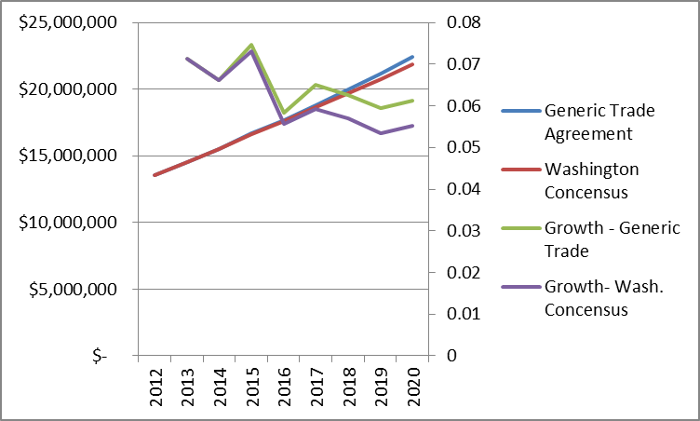

**Corporate Scenarios – Some Ideas on Quantifying Alternatives**

Internal company data is the easiest and most appropriate model to develop. The Scenario Planner highlights import demand by major product categories that should be easily identified in historical sales data within the company databases. It is critical to link total market demand for the countries with the expected demand for company services. This can be tied to the key variables included in the model. A pooled model can be developed efficiently and fit into the framework already within the structural model.

In developing this model we need to be mindful of the two axes of the Transport Scenario (one possible choice). On the one hand there is innovation strategies which can be measured by changes in businesses processes – the move from written manifests to electronic manifests, new service offerings, or customer surveys with respect to quality of services, or other factors not easily quantified.. Quality surveys from customers collected and then measured against demand after taking into account the nominal growth in import demand of the country may be one measure. For example, if you introduce a new service that is an improvement, better tracking, etc. you might give this a numeric number or simply note using dummy or instrumental variables (these tend to be zero before the introduction of the service and 1 after). If you have some numerical indicator of customer satisfaction over time or a measure of how many return customers you have this may be developed into another indicator.

Developing these non-price indicators that measure innovation and quality of service is an art, but it is a useful art as it allows managers to judge which improvements matter and which do not.

Let’s imagine a very simple model for air and for ocean freight :

1. Company Volume by Product Group by Importing Country (matched to the products in the spread sheet model or some other set of indicators) =
   1. Function of:
      1. Import Market Demand (by country) – from the spread sheet model
      2. Other General Economic factors (GDP, Urban Population, Global Trade (all commodities together for the world).
      3. Price of services – cost per kilo or ton by mile
      4. Frequency of service to import market or average length of vogage (based on routing decisions)
      5. Company share of total imports
      6. Quality of service measures or measures of innovation

A separate model for ocean and air can be developed. QuERI has estimates of air and ocean volumes between each of the 72 countries and major regions that can be used to split the volume of trade between air and ocean in terms of value or even volume (although weight measures are not useful as ocean weights dwarf air weights). The key point is that all that is needed to relate outside measures to internal sales and performance data is company data on performance alone. The statistical models can sort out differences in market segments (air and ocean) or routes (Asia versus Europe).

Once this kind of model is developed then using a similar technique as described for the global market model each of the scenarios can be tested. In the **Profit City** world there is less competition and prices for transport go up. Running in Place may be a scenario where there is no change in the underlying prices, innovations in service, frequency of service, and the forecast depends solely upon the expected trade coming out of the four economic scenarios. **Steady As She Goes** assumes slower growth in trade (adjustments to each of the four scenarios) and no innovations or even reducing some of the higher cost innovations to improve profits. And **Dog Eat Dog** prices are cut to the bone to see if they can induce increases in company market share. There is no innovation and bare bones service, even slower service, is offered. In a weak economic environment there is less urgency. Shift of more trade from air to ocean even for higher valued products.

Extending the spread sheet model then to integrate company actual data with economic and some non-economic (from company other other information) adds significant value to this approach. A new baseline for world output and trade then can drive expected growth in company sales into and out of key regions. This kind of “Integrated Planning System” can be helpful especially when outside events – a new oil embargo, war in the Middle East, or the collapse of the Chinese bubble change the global economic environment suddenly. Managers with this kind of quantitative models tied to structural rather than ARIMA or trend forecasts will be able to respond to upper management’s questions with more authority.

Like Shell Oil, companies that use scenarios wisely and develop models tying company data to external information can be winners in a changing world. As Paul Laudicina of AT Kearney points out in his book ***Beating the Global Odds*** that companies that think proactively about the future will be winners in the today’s turbulent business environment. He says that “What really helps is learning to think in terms of scenarios, as we naturally crave exact forecasts (and the illusion of certainty). Scenario thinking opens us up to a range of new possibilities that we never before considered, and it also forces us to be skeptical of our unusual sources. Taken together, these approaches create the basis for principled, decisive action that creates lasting value – and that’s how you beat the global odds.”

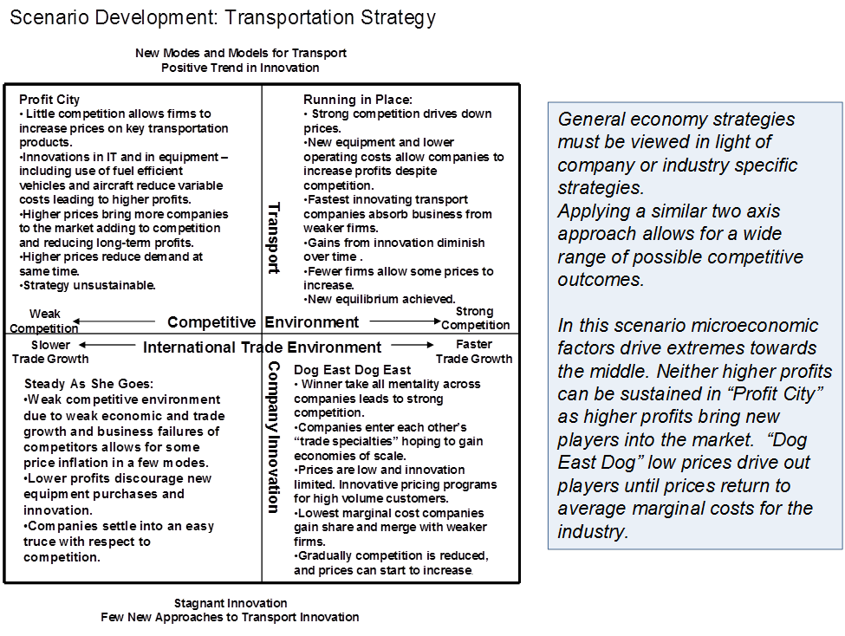

1. Two dimensional scenarios are easiest to deal with, but there could be three dimensional or even n-dimensional structures for complex business or social-economic scenario developments. Three dimensional might relate two dimensional four quadrant scenarios across time periods.
2. Gem*Star reactors use accelerators to produce power comparable to coal fired plants without danger of explosion by adding neutrons with linear accelerators producing a non-sustainable chain reaction. Such reactors could be built for between $ 200 and $ 400 million dollars for 200 megawatt units. Reactors could turn heat into fuel or electricity producing electricity at around $ .02 per kilowatt and diesel fuel from wood, animal wastes, or other cellulose byproducts for around $ 2.00 per gallon.
3. QuERI maintains possibly the largest global integrated model based data set covering trade, industrial development, market demand, and bilateral trade by mode of transport and value of any company in the world. It will be available directly from the company or through a platform developed in cooperation with Emerging Markets Direct making it possible to get timely historical and forecast data through the Internet link anywhere in the world. Data bases are available at various levels of detail – from broad aggregates to detailed NAICS6 level commodity detail for 72 countries covering the period 1990 – 2025.
4. While the pure Republican ultra conservatives might think that withdrawing government will speed economic growth, this “theory” has never been proved statistically. Thus when government spending is cut in the past economic growth has slowed or reversed, and when stimulus is offered or incentives, economic growth tends to respond positively.
5. In the future one modification that might be made would be to have the link to the scenario assumption file for each of the trade modules.
6. Sometimes during earlier periods when tariffs were reduced (at the end of the MTN negotiations or when countries join the EU) models are used to estimate the effects. In these cases prices are adjusted down to reflect the lack of duties at the borders. Modifications can, however, be made to allow for these type of fixed parameter adustments.